*1. Graph decoding: describing the graph in terms of marks, channels and mapping between data and its graphical components.*

**Marks:** Areas

**Visual Channels:** Size (Area - amount of pounds), Color (HUE and brightness of 7 colors), Shape (Rectangular)

**Data Items:** fields

**Data Attributes:** 7 categories (Giving, Spending, Fighting, Hoarding, Lending, Bailing, Earning)

*2. Graph critique: criticizing the task in terms of how well the graphical encoding used supports effective communication of the data and the message.*

Let’s start to critique the given graph by evaluating effectiveness. The author of this graph used area as an visual channel. According to the instructor of this course, the area is considered to be as one of the least expressiveness type of the channels since it is very difficult to evaluate the size.

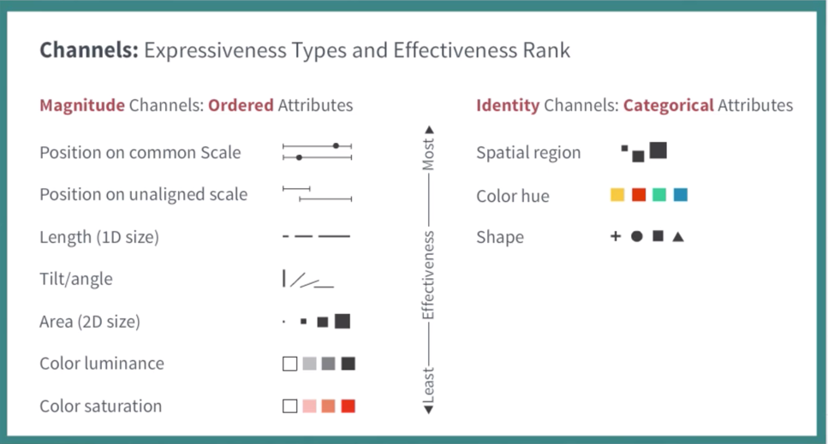

For instance, if you get rid of labels and start to compare values, it is very challenging to compare and identify which data items value is bigger or smaller:

 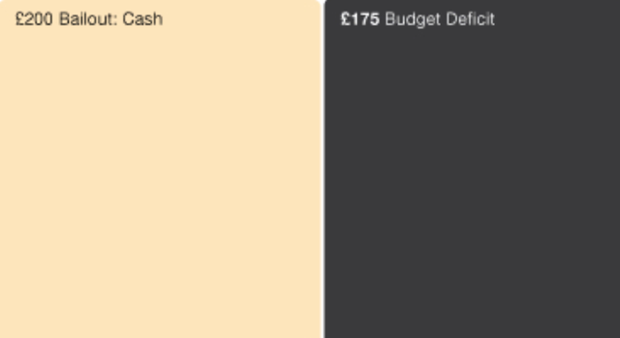

Another issue of the chart is the size of the labels. Fortunately, I can zoom in using zoom inspector, however, using that small text labels are not very useful for others to understand the graph. Also, the size of labels are not proportional to the size of areas. For instance, Bailout : **Asset Purchasing & Lending** has the size of 400£ that occupies only 5% part of rectangular, while **Aid** item has the size of 5£ that occupies 80% of rectangular. Moreover, one of the element shape is too small that the label does not fit:



Additionally, the author of the graph used colors (HUE and brightness) in order to distinguish categories. However, it is not very clear at glance what color belongs to category. For example, it is very likely to identify Trident and Mortgage Lending as one category since the color is ambiguous. Nevertheless, they belong to different types of category.



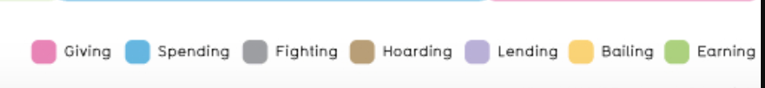

*3. Graph redesign: designing and developing a new version of the graph that addresses the problems identified in the graph critique step.*

